Experiment No. 3
Aim: Implementation of a given problem statement/s for different types of inheritance.
- Write a Java program to create a class known as "BankAccount" with methods called deposit() and withdraw(). Create a subclass called SavingsAccount that overrides the withdraw() method to prevent withdrawals if the account balance falls below one hundred.

class BankAccount {
protected double balance;
public BankAccount(double balance) {
this.balance = balance;
}
public void deposit(double amount) {
if (amount > 0) {
balance += amount;
System.out.println("Deposited: " + amount);
System.out.println("Balance: " + balance);
} else {
System.out.println("Invalid deposit amount.");
}
}
public void withdraw(double amount) {
if (amount > balance) {
System.out.println("Insufficient balance.");
} else {
balance -= amount;
System.out.println("Withdrawn: " + amount);
System.out.println("Balance: " + balance);
}
}
}
class SavingsAccount extends BankAccount {
public SavingsAccount(double balance) {
super(balance);
}
@Override
public void withdraw(double amount) {
if ((balance - amount) < 100) {
System.out.println("Withdrawal denied! Minimum balance of 100 must be maintained.");
} else {
balance -= amount;
System.out.println("Withdrawn: " + amount);
System.out.println("Balance: " + balance);
}
}
}
public class Main {
public static void main(String[] args) {
SavingsAccount sa = new SavingsAccount(500);
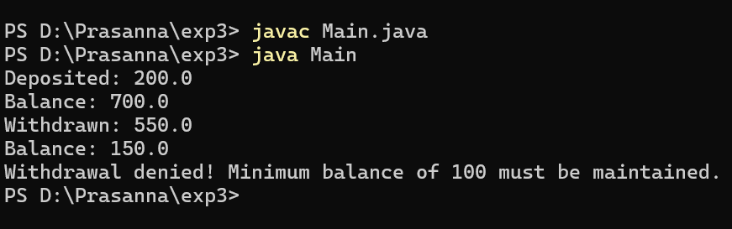
sa.deposit(200);
sa.withdraw(550);
sa.withdraw(100);
}
}

- Write a Java program that creates a class hierarchy for employees of a company. The base class should be Employee, with subclasses Manager, Developer, and Programmer. Each subclass should have properties such as name, address, salary, and job title. Implement methods for calculating bonuses, generating performance reports, and managing projects

class Employee {
protected String name;
protected String address;
protected double salary;
protected String jobTitle;
public Employee(String name, String address, double salary, String jobTitle) {
this.name = name;
this.address = address;
this.salary = salary;
this.jobTitle = jobTitle;
}
public double calculateBonus() {
return salary * 0.05;
}
public void generatePerformanceReport() {
System.out.println("Performance report for " + name + " (" + jobTitle + ")");
}
public void manageProjects() {
System.out.println(name + " is managing general tasks.");
}
}

class Manager extends Employee {
public Manager(String name, String address, double salary) {
super(name, address, salary, "Manager");
}
@Override
public double calculateBonus() {
return salary * 0.20;
}
@Override
public void generatePerformanceReport() {
System.out.println("Manager " + name + " performance: Excellent leadership.");
}
@Override
public void manageProjects() {
System.out.println("Manager " + name + " is overseeing multiple projects.");
}
}
class Developer extends Employee {
public Developer(String name, String address, double salary) {
super(name, address, salary, "Developer");
}
@Override
public double calculateBonus() {
return salary * 0.10;
}
@Override
public void generatePerformanceReport() {
System.out.println("Developer " + name + " performance: Strong coding skills.");
}
@Override
public void manageProjects() {
System.out.println("Developer " + name + " is working on development tasks.");
}
}
class Programmer extends Employee {
public Programmer(String name, String address, double salary) {
super(name, address, salary, "Programmer");
}
@Override
public double calculateBonus() {
return salary * 0.08;
}
@Override
public void generatePerformanceReport() {
System.out.println("Programmer " + name + " performance: Efficient programming.");
}
@Override
public void manageProjects() {
System.out.println("Programmer " + name + " is handling coding assignments.");
}
}
public class Main {
public static void main(String[] args) {
Manager m = new Manager("Amit", "Pune", 80000);
Developer d = new Developer("Neha", "Mumbai", 60000);
Programmer p = new Programmer("Ravi", "Nagpur", 50000);
System.out.println("Manager Bonus: " + m.calculateBonus());
m.generatePerformanceReport();
m.manageProjects();
System.out.println();
System.out.println("Developer Bonus: " + d.calculateBonus());
d.generatePerformanceReport();
d.manageProjects();
System.out.println();
System.out.println("Programmer Bonus: " + p.calculateBonus());
p.generatePerformanceReport();
p.manageProjects();
}
}
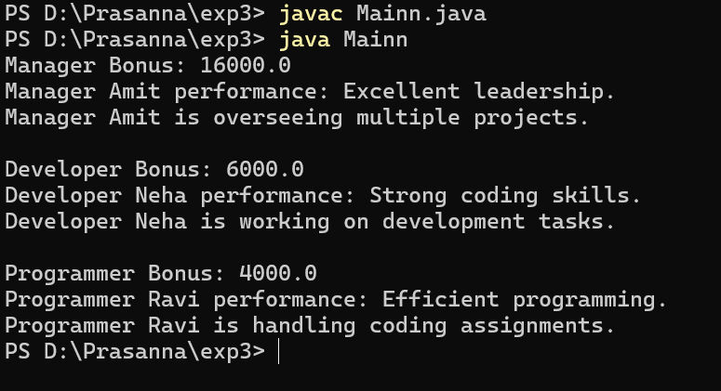

- Implement Following: a. Create abstract class shapes with dim1, dim2 variables and abstract area() method. Class b. rectangle and triangle inherits shape class. Calculate area of rectangle and triangle.

abstract class Shape {
protected double dim1;
protected double dim2;
public Shape(double dim1, double dim2) {
this.dim1 = dim1;
this.dim2 = dim2;
}
abstract double area();
}
class Rectangle extends Shape {
public Rectangle(double dim1, double dim2) {
super(dim1, dim2);
}
@Override
double area() {
return dim1 * dim2;
}
}
class Triangle extends Shape {
public Triangle(double dim1, double dim2) {
super(dim1, dim2);
}
@Override
double area() {
return 0.5 * dim1 * dim2;
}
}
public class Main {
public static void main(String[] args) {
Rectangle r = new Rectangle(10, 5);
Triangle t = new Triangle(10, 5);
System.out.println("Rectangle area: " + r.area());
System.out.println("Triangle area: " + t.area());
}
}

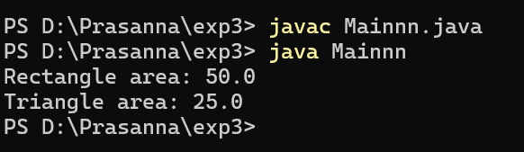

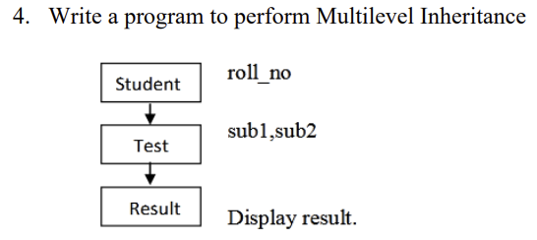
class Student {
protected int roll_no;
public void setRollNo(int roll_no) {
this.roll_no = roll_no;
}

public void displayRollNo() {
System.out.println("Roll No: " + roll_no);
}
}
class Test extends Student {
protected int sub1, sub2;
public void setMarks(int sub1, int sub2) {
this.sub1 = sub1;
this.sub2 = sub2;
}
public void displayMarks() {
System.out.println("Subject 1: " + sub1);
System.out.println("Subject 2: " + sub2);
}
}
class Result extends Test {
public void displayResult() {
int total = sub1 + sub2;
double avg = total / 2.0;
displayRollNo();
displayMarks();
System.out.println("Total: " + total);
System.out.println("Average: " + avg);
}
}
public class Main {
public static void main(String[] args) {
Result r = new Result();
r.setRollNo(101);
r.setMarks(85, 90);
r.displayResult();
}
}

